PROBABILITY ASSIGNMENT 5

SUBMITTED BY TARUSHI GERA

102103391, 2COE29

1.

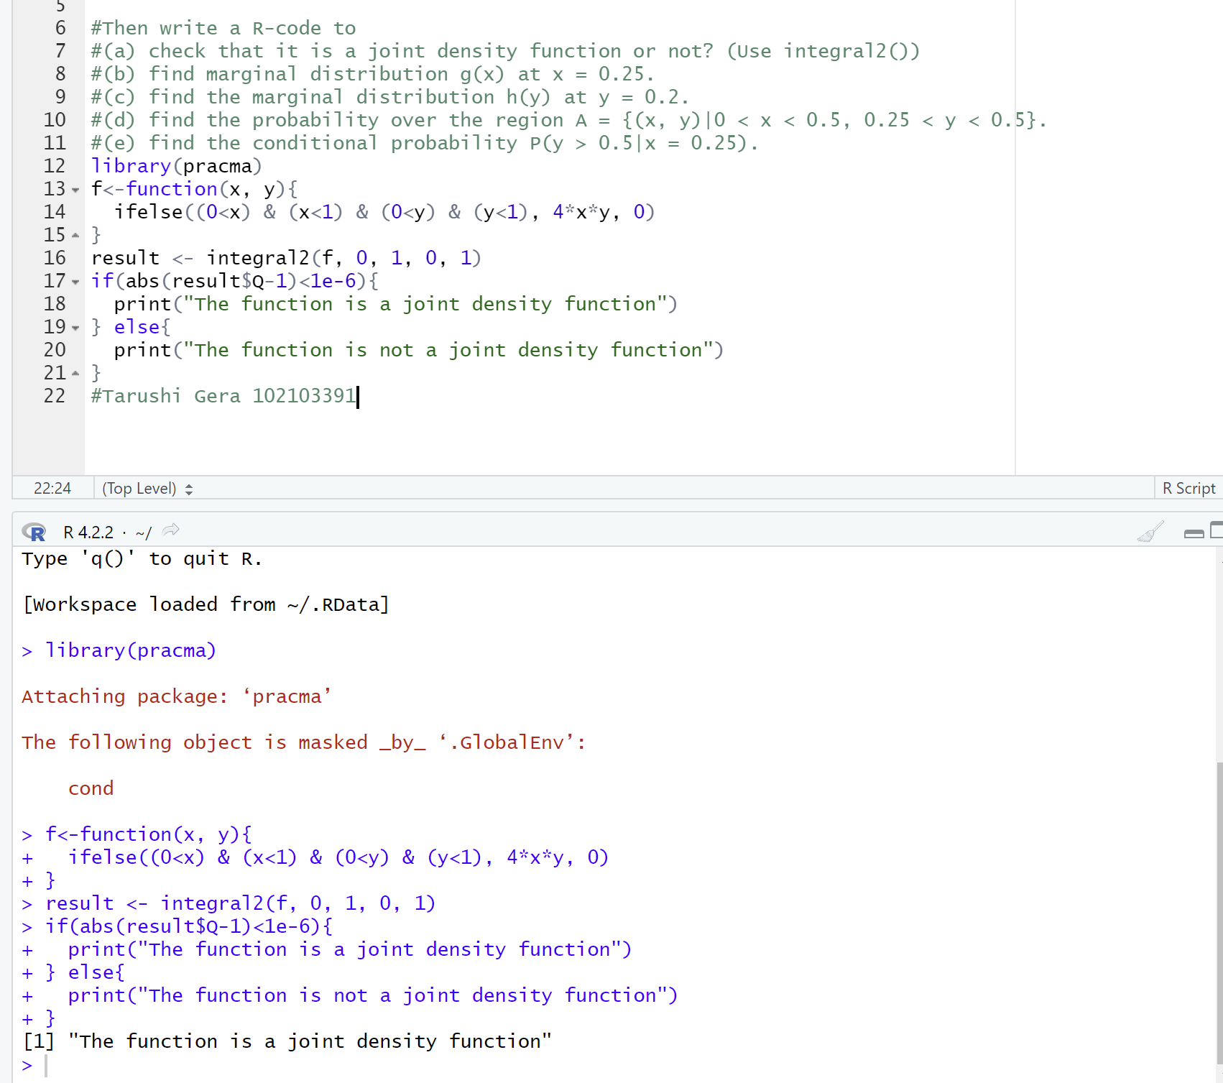

2.

